EREJEPOV JARASBAY

4-Topshiriq

4) x,y sonlar berilgan.Jumlani rostlikka tekshiring.Koordinata (x,y) bolgan nuqta koordinata choragining birinchi yoki uchinchi choragida yotadi. Dastur PyQt5paketidan foydalanib tuzilsin.

KODI:

from PyQt5.QtWidgets import *

import sys

from PyQt5 import uic

app = QApplication([])

ui=uic.loadUi("4-topshiriq.ui")

def OK():

koordinatx=ui.x.displayText()

koordinaty=ui.y.displayText()

if int (koordinatx)<0 and int(koordinaty)<0 or int (koordinatx)>0 and int(koordinaty)>0:

ui.natija.setText("nuqta 1 yoki 3 chorogda")

else:

ui.natija.setText("nuqta zarur chorogda emas")

ui.OK.clicked.connect(OK)

ui.show()

app.exec_()

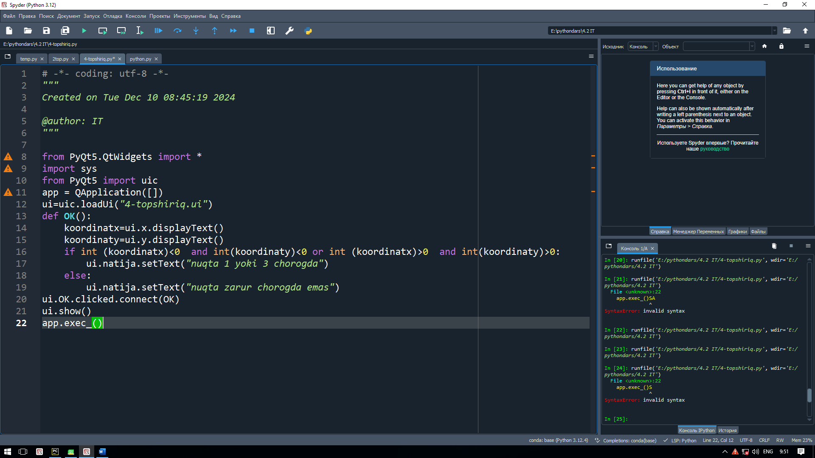

NATIJA:

